**Game HUD Redesign**

For the Game HUD redesign, we were tasked to redesign a UI system of our choice. A UI system that i wanted to redesign what the Hogwarts legacy gear HUD. This was because when the game originally came out many people had issues that the gear HUD liked the destiny gear HUD, and it does not read well and has many points of redundancy. The game has six large pictures of swappable items and despite how much space they take it leaves most of the canvas very empty. First, I did research on how JRPG’s display gear; in my experience of playing the game the player acquires a lot of gear and it needs a better way displaying them. Another problem the game has is displaying upgraded pieces of gear, it shows a simply dot although it's the same display for level 1,2,3 gear. I also wanted to split the cosmetics from the equipment since it's a hassle to switch to better gear and changing clothes every time you find better gear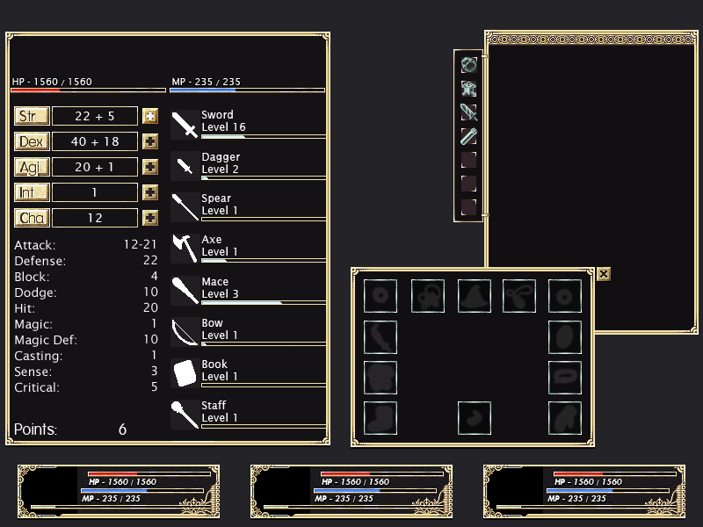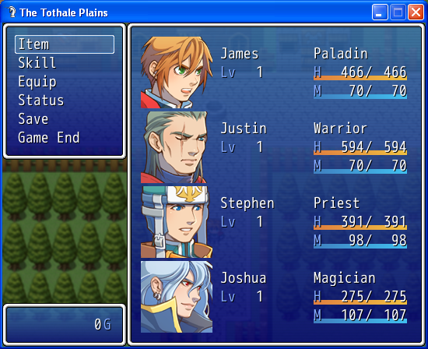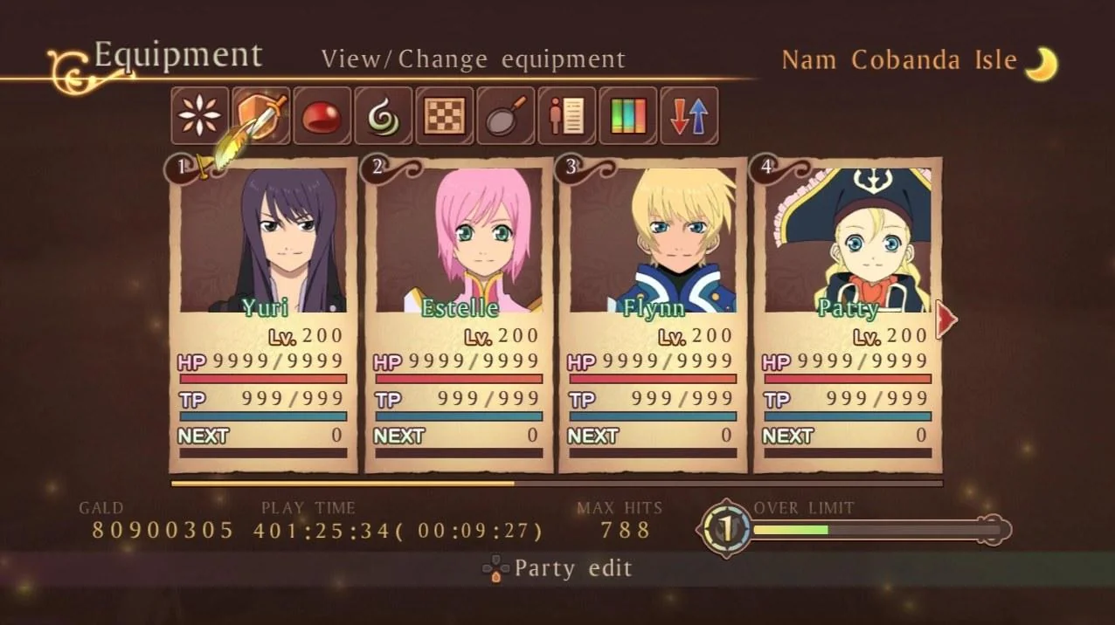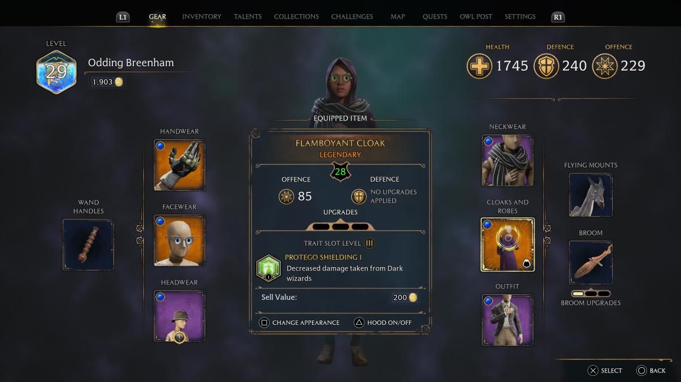

**Template HUD**

For the templet redesign i thought it was interesting to do the Doom X Animal Crossing HUD, it was an interesting mash up when the games came out together. I did research on doom by watching YouTube videos of play throughs to get a better understanding of the game since i did not play it myself same with AC. I had some concept challenges like if I should have AC elements in doom or Doom elements in AC, but it made more sense to do the former since the construct overly would be for an FPS. I took on the project by sections, grabbing source material from both games and working on UI in a counterclockwise workflow. I had issues towards the end with illustrator constantly crashing but I finally got it done.